# 07. Canada

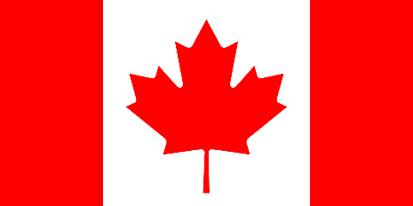2nd largest country in the world (after Russia)

Consist of 10 provinces and 3 territories

## Geography

in Northern part of North America

the Mackenzie Mount, Rocky Mountains

Highest mountain: Mt. Logan 6050m

5 great Lakes: Erie, Huron, Michigan, Ontario, Superior

## Climate

The majority of Canada has a cold or severely cold winter climate

Southerly areas are warm in summer

Area near The Greats Lake is warmer in winter (lakes stabilized temperature) 🡪 temperature rarely go under zero of Celsius

## Important cities

Capital is Ottawa

Montreal – largest

Toronto – the most populated city

Vancouver – XXI. Winter Olympic Games

Edmonton – centre of heavy industrial in Canada

## Political system

Constitution monarchy lead by Queen (Elizabeth II)

General Governor represents queen

Parliament democracy with federal layout

## Population

About 35 million people

One of the least dense populations in the world

## Languages, history

Official languages are English, French

French is rather used in province of Quebec

Canada was established in 1867 when received independence on United Kingdom

## Other

Borders with the USA longest border in the world (5500 km)

Maple leaf, Curling, Ice Hockey, NHL, Lacrosse